Question #1
Opening Task Name and Age

Content Area: Lifelong Learning Practices

Standard Alignment: LLP 3 yr.4.1: Demonstrate awareness of identity including personal information, characteristics, preferences, and abilities (for example, name, age, gender, physical attributes, likes/dislikes, parent/caregiver, family members).

INSTRUCTIONS (Read aloud script in bold)
“My name is . What is your name?” Pause for response.
“How old are you?” Pause for response.
“What is your mother’s name?” Pause for response.
“What are your brothers and sisters’ names?” Pause for response.

SCORING
1 pt. each correct response (4 pts. possible.)
Write students response on scoring sheet.

Question #2: VOCABULARY

Content Area: English Language Arts

Standard Alignment: ELA 3 yr.1.2: Begin to understand and use nouns, verbs, prepositions, and pronouns.
ELA 3 yr.1.3: Begin to ask and answer simple questions (for example, who, what, where).
INSTRUCTIONS (Read aloud script in bold)

Display the Student Materials sheet for question #1.
“Look at this picture of a teacher and some children in a classroom. The children are doing many different activities.”
Teacher gives the following prompts:
I Prompt 1 “Point to the child with the blocks.” Pause for response up to 5 seconds.
I Prompt 2 “Point to the cookies in the oven.” Pause for response up to 5 seconds.
I Prompt 3 “Point to a book on the shelf.” Pause for response up to 5 seconds.
I Prompt 4 “Point to the ball under the table.” Pause for response up to 5 seconds. Mark on the Scoring Sheet how the student responded.
SCORING
1 pt. for pointing or gesturing to the correct object (4 pts. possible)
0 pts. for pointing or gesturing to the wrong object, or for not pointing or gesturing at all
MATERIALS | SAMPLE RECORD OF RESPONSE
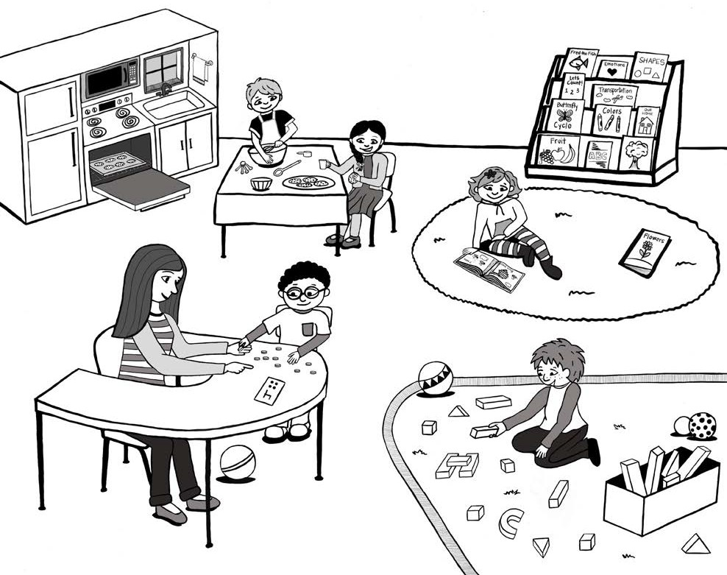 | 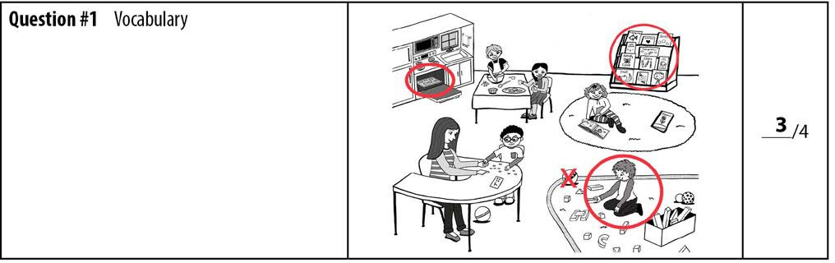

Question #3:
BODY PARTS

Content Area: English Language Arts

Standard Alignment:

INSTRUCTIONS (Read aloud script in bold)
“Where are your arms?” Pause for response.
“Where are your hands?” Pause for response.
“Where are your fingers?” Pause for response.
“Where are your elbows?” Pause for response.
“Where are your shoulders?” Pause for response.
“Where is your chin?” Pause for response.
“Where is your cheek?” Pause for response.
“Where is your tummy?” Pause for response.
“Where are your legs?” Pause for response.
“Where are your knees?” Pause for response.
“Where are your feet?” Pause for response.
“Where are your toes?” Pause for response.
“Where is your back?” Pause for response.
“Where is your head?” Pause for response.
“Where is your neck?” Pause for response.
“Where are your ears?” Pause for response.
“Where is your nose?” Pause for response.
“Where are your eyes?” Pause for response.
SCORING
1 pt. for each correct response (18 pts. possible)
Put an (x) on each body part that they do not know.

Question #4: CONCEPT OF LETTER/NUMBER

Content Area: English Language Arts

Standard Alignment: ELA 3 yr.2.3: With prompting and support, identify print in everyday life including numbers, alphabet letters, letters in their own name, and environmental print.

INSTRUCTIONS (Read aloud script in bold)
Display the Student Materials sheet for question #4. “Point to a number.” Pause for the student to point. “Now point to a letter.” Pause for the student to point. Put an (x) on the object they pointed to if incorrect. Circle the object they pointed to if correct.
A. Concept of number (1 pt. possible)
SCORING
- 1 pt. for pointing to a number
B. Concept of letter (1 pt. possible)
- 1 pt. for pointing to a letter

MATERIALS | SAMPLE RECORD OF RESPONSE
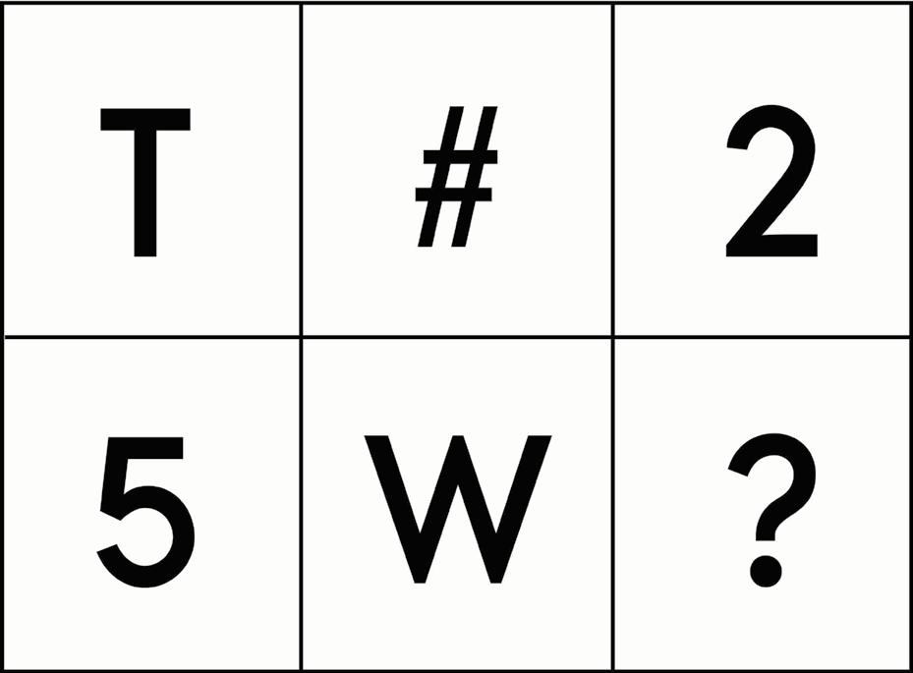 | 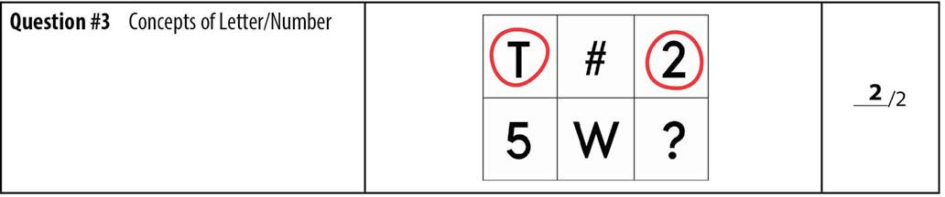

Question #5:
WRITING STROKES

Content Area: English Language Arts/Motor

Standard Alignment: ELA 3 yr.3.1: With prompting and support, begin to experiment with writing and represent ideas visually (for example, scribbles, stamps, gluing pictures on paper).

INSTRUCTIONS (Read aloud script in bold)
I. Give the student the Student Materials sheet for Question #5 and a pencil. (The Student Material sheet may be copied on paper for students to mark or placed in a sheet protector to mark with a marker.) Point to the box with the line or shape. Do not trace the line or shape. “Please draw this line (shape) (point to the empty box) here.” Repeat this direction for each line or shape.
II. Check to see if they are holding the pencil the correct way. (Should pinch the pencil and crayon with their forefinger and thumb placing their other fingers underneath the pencil. Mark on the Scoring Sheet how the student responded.)
SCORING
A. 1 pt. for each recognizable or correct line or shape (4 pts. possible)
B.1 pt. for holding the pencil the correct way
To be correct, the student must demonstrate the properties of the shape (for example, a circle must be closed; the vertical-horizontal cross must be two intersecting lines).

MATERIALS | SAMPLE RECORD OF RESPONSE
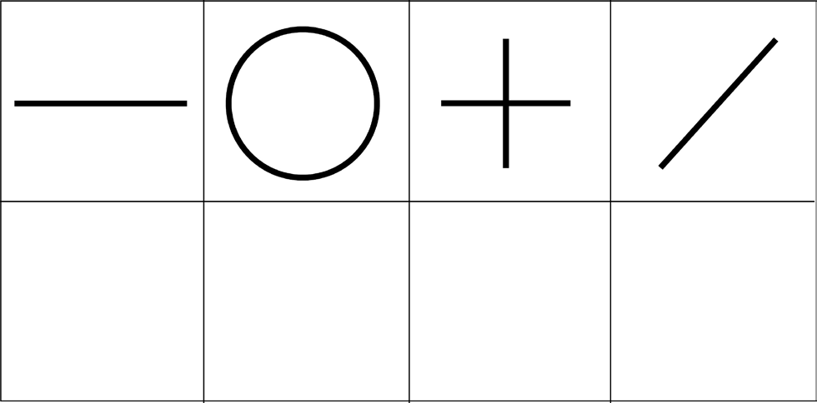 | 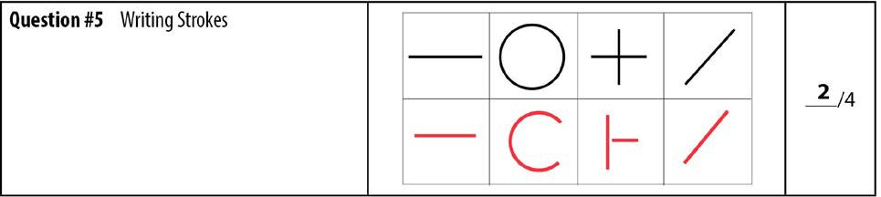

Question #6: ORAL LANGUAGE

Content Area: English Language Arts

Standard Alignment: ELA 3 yr.1.3: Begin to ask and answer simple questions (for example, who, what, where).
ELA 3 yr.1.4: With prompting and support, describe attributes of familiar people, places, things, and events.
ELA 3 yr.1.8: With prompting and support, engage in
conversations with peers and adults.
INSTRUCTIONS (Read aloud script in bold)
Prompt the student with the following statements. If the student answers with 5 or more words in one complete sentence that is on topic, disregard the additional prompts, score the student response, and move on to Question #7.
I Prompt 1 “Tell me about your favorite toy.” Pause for the student’s response. Ask a follow-up question if the child does not respond with 5 or more words in one complete, on-topic sentence “What else can you tell me about ?”
If the student answers with 5 or more words in one complete sentence that is on topic, score the student response and move on to Question #7.
I Prompt 2 “Tell me who you like to play with.” Pause for the student’s response. Ask follow-up question if child does not respond with 5 or more words in one complete, on-topic sentence “Tell me why you like to play with .”
If the student answers with 5 or more words in one complete sentence that is on topic, score the student response and move on to Question #7.
I Prompt 3 “Tell me about your favorite place to go.” Pause for the student’s response. Ask follow-up question if child does not respond with 5 or more words in one complete, on-topic sentence “Tell me more about why you like to go to .”
Mark on the Scoring Sheet how the student responded.

SCORING
Oral Language Responses (Score is based on the student’s production of an oral response, not the content of their response)
Score is based on the student’s response with the most words. (5 pts. possible)

- 5 pts. 5 or more words in one complete sentence

- 4 pts. 4 words in one complete sentence
- 3 pts. 3 words in one complete sentence
- 2 pts. 2 word response or an incomplete sentence
- 1 pts. 1 word responses
- 0 pts. There is no student response
Question #7:
SHAPE DISCRIMINATION

Content Area: Mathematics

Standard Alignment: Math 3 yr.4.1: Match, point to, and begin to identify basic shapes by name.

INSTRUCTIONS (Read aloud script in bold)
Display the Student Materials sheet for question #7. “Here are some shapes.”
Point to the circle on the page. “What shape is this?” Pause for response.
Point to the square on the page. “What shape is this?” Pause for response.
Point to the triangle on the page. “What shape is this?” Pause for response.
Point to the rectangle on the page. “What shape is this?” Pause for response.
Discontinue rule
If the student pauses for 5 seconds, repeat the instructions. If the student is still unable to respond after 5 seconds, record a score of 0, and proceed to the next shape.
SCORING
1 pt. for each correctly identified shape (4 pts. Possible)
MATERIALS | SAMPLE RECORD OF RESPONSE
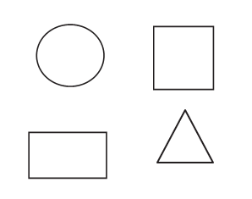

Question #8:
ROTE COUNTING

Content Area: Mathematics

Standard Alignment: Math 3 yr.1.1: Count to ten by ones.

INSTRUCTIONS (Read aloud script in bold)
“Please count.” If the student doesn’t start at 1 or count aloud, then prompt once, “Please start at one, and count out loud.” Listen to the student count as high as possible up to 10. Record the last number the student said correctly, before an error, up to 10.
The number of points awarded is the highest number reached by correctly counting from 1 to 10. The score should not exceed 10 points, even if the student counted correctly to a number greater than 10. (10 pts. possible)
SCORING
MATERIALS | SAMPLE RECORD OF RESPONSE
NONE | 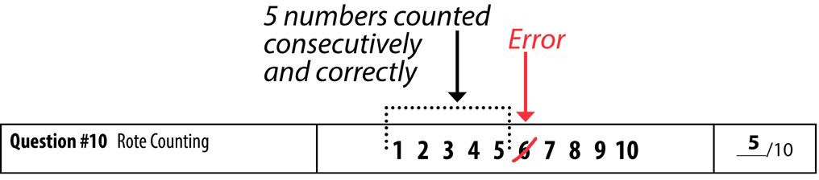

Question #9:
NUMERAL RECOGNITION

Content Area: Mathematics

Standard Alignment: Math 3 yr.1.3: Begin to recognize the difference between letters and numbers.

INSTRUCTIONS (Read aloud script in bold)
Display the Student Materials sheet for question #9. “I will point to each number, and you tell me the name of the number.” Begin with the number 3 and proceed left to right and top to bottom. Pause for up to 3 seconds on each number to allow for the student to respond. If the student does not respond within 3 seconds, proceed to the next number.
II. Mark incorrect and skipped responses with a slash through the number to indicate no score, and leave the correct responses unmarked. Record the number of correctly named numbers on the Scoring Sheet.
SCORING
1 pt. for each correctly identified numeral (6 pts. possible)

MATERIALS | SAMPLE RECORD OF RESPONSE
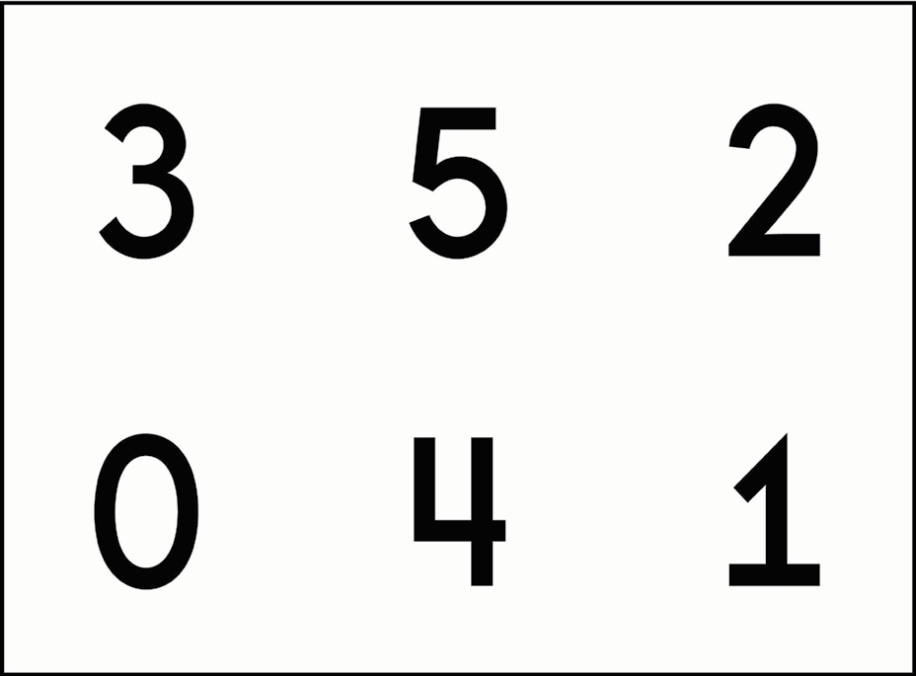 | 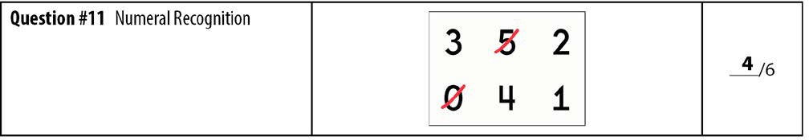

Question #10:
COLOR RECOGNITION

Content Area: Mathematics

Standard Alignment:

INSTRUCTIONS (Read aloud script in bold)
Point to the apple, “What color is this?” Pause for response
Point to the sun, “What color is this?” Pause for response
Point to the bird, “What color is this?” Pause for response
Point to the grass, “What color is this?” Pause for response
Point to the orange, “What color is this?” Pause for response
Point to the grapes, “What color is this?” Pause for response
Point to the cloud, “What color is this?” Pause for response
Point to the black box, “What color is this?” Pause for response
Point to the dog, “What color is this?” Pause for response
Point to the pig, “What color is this?” Pause for response

SCORING
1 pt. for each correctly identified color (10 pts. possible)

Question #11:
SORTING

Content Area: Mathematics

Standard Alignment: Math 3 yr.3.3: Sort objects into given categories including color, size, shape, etc.
INSTRUCTIONS (Read aloud script in bold)

Begin with a set of 12 identical manipulatives that includes 4 red, 4 yellow, and 4 blue manipulatives that do not vary in shape or size. Manipulatives are limited to cubes, circle counters/ chips, math tiles, or teddy bears.
Hold up the manipulatives and say, “I have these ____________________(blocks, chips, cubes, etc.), please sort these ________________________by color.” Place the manipulatives on the table in front of the student. Pause for the student’s response. Record on the Scoring Sheet. If the student does not respond, repeat the instructions. If the student still does not respond, record a score of zero.

SCORING
1 pt. for correctly sorting by color

MATERIALS
4 red manipulatives
4 yellow manipulatives
4 blue manipulatives

Question #12:
PATTERN

Content Area: Mathematics

Standard Alignment:
INSTRUCTIONS (Read aloud script in bold)
” I am going to clap a pattern and I want you to listen carefully” clap the pattern: clap…......clap…........clap. “Okay, now you try it”
“Now I am going to clap another pattern” clap the pattern: clap……...clap clap…......clap…........clap. “Okay, now try that one”
If they get it wrong, tell them to try again. If it looks like they are close, give them a few more tries. If they look like they don't understand, go to the next instruction
SCORING
1 pt. for correctly copying the pattern

Question #13:
LETTERS AND THEIR SOUNDS

Content Area: English Language Arts

Standard Alignment: ELA 3 yr.2.14: With prompting and support, begin to identify the names and sounds of some upper- and lowercase letters of the alphabet, including those in their own name.

INSTRUCTIONS (Read aloud script in bold)
“Sing the ABC Song” Pause for response.
“Do you know all your letters and their sounds?” Pause for response. If they do not, move on to the next part of the interview. If they do, continue the question.
I Hold up the lowercase LPC (Letter picture flashcards) showing one card at a time in a random order, ask student what letter it is and what sound it makes.
I Hold up the Uppercase LPC showing one card at a time in a random order, ask student what letter it is.
I Mark incorrect and skipped responses with a slash through the letter pair to indicate no score, and leave the correct responses unmarked. Record the number of correct letter sounds on the Scoring Sheet.
SCORING
1 pt. for singing the song correctly (1 pts possible)
1 pt. for each upper letter name correct (26 pts. possible)
1 pt. for each lower letter name correct (26 pts. possible)
1 pt. for each lower letter sound correct (26 pts. possible)

Question #14:
Fine Motor Skills

Content Area: Motor

Standard Alignment:

INSTRUCTIONS (Read aloud script in bold)
Hand them a pair of scissors and the dotted line paper,” Will you cut out one of these lines with the scissors?” Give them time to cut it out.

SCORING
1 pt. for correctly holding scissors (1 pt. possible)
1 pt. for correctly cutting the line (1 pt. possible)

Question #15:
Gross Motor Skills

Content Area: Motor

Standard Alignment:

INSTRUCTIONS (Read aloud script in bold)
Run- Place two cones 50 feet apart. Make sure there is at least 8 to 10 feet of space beyond the second cone for a safe stopping distance. “Run as fast as you can from one cone to the other when I say Go.” “GO”
Repeat a second trial if they couldn't do it the first time.
Jump- Mark off a starting line on the floor. “Start behind this line and jump as far as you can.”
Repeat a second trial if they couldn't do it the first time.
Walk Backwards- hand the child the string “Hold the string of the toy and pull it while you’re walking backwards” Have them walk until they have gone 3 feet.
Walk up and down the stairs switching feet- “Hold on to the rail and walk up the stairs.” Stand behind them in case they fall.
After they have walked up the stairs, stand on two steps below the child slightly to the left of him/her. “Walk down the steps.”
Balance on one foot- “Are you right-handed or left-handed?” Whichever hand they write with, “Stand on that foot and lift the other foot up off the ground for as long as you can.” Time them and record the time on the score sheet.
If the child needs assistance, have them start by holding onto your hand. Once they have gotten their balance, tell them that you are going to let go, but that they need to keep standing on one foot.
Throw a ball overhand- Show the student how you want them to throw the ball by demonstrating. (Throw it overhand) then give them the ball “Throw it like I did.”

SCORING
I 1 pt. for running correctly
- Arms move in opposition to legs, elbows bent
- Brief period where both feet are off the ground.
- Narrow foot placement landing on heel or toe (i.e not flat footed.)
- Nonsupport leg bent approximately 90 degrees (i.e. close to buttocks)
1 pt. for jumping correctly
- Preparatory movement includes flexion of both knees with arms extended behind body
- Narrow foot placement landing on heel or toe (i.e not flat footed.)
- Arms extend forcefully forward and upward reaching full extension above the head
- Arms are thrust downward during landing
1 pt. for walking backwards correctly
1 pt. for walking up and down the stairs correctly
- Hold on the railing
- Bend the right knee and lift the right foot up and place it on the first step.
- Bend the left knee and lift the left foot up and place it on the second step.
- Keep alternating feet right, left, right, left
1 pt. for balancing correctly
1 pt. for throwing correctly
- Windup is initiated with downward movement of hand/arm
- Rotates hip and shoulders to a point where the nonthrowing side faces the wall.
- Weight is transferred by stepping with the foot opposite the throwing hand.
- Follow-through beyond ball release diagonally across the body toward the nonpreferred side
(6 pts. possible)

Question #16:
Character

Content Area: Character

Standard Alignment:

INSTRUCTIONS (Read aloud script in bold)
- “Do you say your prayers ever night?” pause for response.
- “Can you show me how you sit for meditation and prayer?” pause for response. “What do you do with your arms, eyes, and head?” pause for response.
- “What do you do with your eyes the whole time you are meditating?” pause for response.
- “Who is the leader of our church?” pause for response.
- “When someone gives you a treat or a surprise what do you say?” pause for response.
- “Would you ever take something that did not belong to you?” pause for response.
- “What do you do when your mom or teacher call your name?” pause for response.
- “If you see some garbage on the ground, what should you do with it?” pause for response.
- “If you are in a room with just one chair and mom or dad comes in, would you get up and let them sit down?” pause for response.
- “When you see a teacher in the hallway, should you walk past them and look away, or should you look at them and say hello?” pause for response.
When you are using the bathroom
- “How many squares of tissue do you use?” pause for response.
- “What do you do with the tissue when you are done?” pause for response.
- “What do you do if there is not tissue?” pause for response.
- “Do you flush the toilet?” pause for response.
- “When do you wash your hands?” pause for response.
- “Where do dirty paper towels go?” pause for response.

SCORING
1 pt. for answering each question correctly (16 pts. possible)

